Practical 5

Question 1
Write a program that prompts the user for two numbers, then prints
- The sum
- The difference
- The average
- The result of multiplication of the TWO numbers
To do so, implement a class
public class Pair
{
/**
* Constructs a pair
* @param aFirst the first value of the pair
* @param aSecond the second value of the pair
*/
public Pair(double aFirst, double aSecond)
{

}
/**
* Computes the sum of the values of the pair
* @return the sum of the first and second values
*/
public double getSum()
{

}
.............
.............
.............
}

Question 2
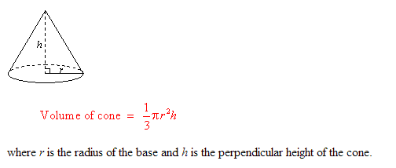

Implement a class IceCreamCone with methods getSurfaceArea() and getVolume(). In the constructor, supply the height and radius of the cone. Be careful when looking up the formula for the surface area, you should only include the outside area along the side of the cone since the cone has an opening on the top to hold the ice cream.
Question 3

Implement a class QuadraticEquation whose constructor receives the coefficients a,b,c of the quadratic equation ax²+bx+c=0. Supply methods getSolution1 and getSolution2 that get the solutions, using the quadratic formula. Write a test class QuadraticEquationTester that constructs a QuadraticEquation object, and prints the two solutions.

Question 4

Implement a class Employee. An Employee has a name(String) and a salary(double). Provide a constructor with TWO parameters
public Employee(String employeeName, double salary)
and methods
public String getName()
public double getSalary
public void increment(double percent) // increase the salary of employee
Create a Tester class and create some objects and test all the methods created.

Question 5

The following program creates a new Rectangle and prints its coordinates.

import java.awt.Rectangle;

public class RectanglePrinter
{
public static void main(String[] args)
{
Rectangle r1 = new Rectangle(0, 0, 100, 50);
/* Your code goes here */
System.out.println(r1);
/* and here */
}
}

Add code to the program above to create a second rectangle with the same values (x, y, width and height) as the first Rectangle. Then, apply the grow method to the second rectangle (grow(10, 20)) and print both rectangles. For more information on the grow method, look at the API documentation.

Question 6
To “capitalize” a string means to change the ﬁrst letter of each word in the string touppercase (if it is not already upper case). For example, a capitalized version of “Now is the time to act!” is “Now Is The Time To Act!”. Write a program that will print a capitalized version of a string to standard output. In your program, you should have a method called getString() to get the input from user and also a methodcalled capitalize() to capitalize the input. Write also a Tester program to test your program.

